MatchAid – Refactor Roadmap (v0)
Page: Registrations (Wix Velo + HTML → GoDaddy PHP + HTML/JS)
Date: 2026-02-09

1. Purpose
This document defines the functional requirements and refactor plan to replatform the Wix Admin/Player Portal “Registrations” page to the GoDaddy target architecture, following established MatchAid refactor standards (bootstrap, chrome, shared CSS/JS, service/context patterns, and database services). The intent is to preserve the existing user workflow, data rules, and UI look-and-feel while removing Wix HTML component postMessage/iframe dependencies.
Contents
- Source Artifacts (Inputs)
- Current Wix Behavior Summary (As-Is)
- Target Architecture (To-Be)
- UI/UX Direction (Target Screens)
- Functional Requirements
- Endpoint / Function Inventory
- Data & Contracts
- Refactor Roadmap – Step-by-step
- Open Decisions / Placeholders

2. Source Artifacts (Inputs)
Provided for this page:
- Wix Velo page controller: Matchaid JS - Admin Player Registration 2026-01-27a.js
- HTML Component UI: Matchaid HTML - Registrations 2026-01-17a.html
- UI direction screenshots (Roster / Add Self / Favorites / GHIN / Non-Rated) – included in Section 5
Existing GoDaddy assets to leverage (already in place):
- bootstrap.php (absolute path constants + config)
- chromeHeader.php / chromeFooter.php (global shell + footer navigation + status line)
- ma_shared.css (global tokens + shared components)
- ma_shared.js (apiPostJson/api routing helpers, setStatus, common DOM utilities)
- service_ContextUser.php and service_ContextGame.php (session context + auth guard patterns)
- service_dbPlayers.php / service_dbFavPlayers.php (query/upsert/delete patterns; if present, extend as needed)
- pageRouter.php (central navigation; no hardcoded URLs)

3. Current Wix Behavior Summary (As-Is)
The Wix implementation has two cooperating layers:
- Velo controller orchestrates context (user + game), calls Wix/GHIN backends, and posts INIT/render payloads to the HTML component.
- HTML component renders the multi-tab UI and sends user interactions back to Velo via postMessage.
User workflow (high level):
- User opens Registrations for the currently selected game (GGID stored in session).
- Tabs are available: Roster, Add Self, Favorites, GHIN, Non-Rated.
- All enrollment actions ultimately result in assigning a tee set to a selected player, then inserting/updating a db_Players record.
- Roster list reflects enrolled players immediately after add/remove/tee-change operations.
Key interactions and behaviors:
- Roster rows show: Name • Tee • CH on line 1, and HI • PH • SO • Pair on line 2, plus Favorite (heart) and Remove (trash) icons.
- Tapping a roster row opens a Tee Picker modal. The currently assigned tee is pre-selected (if present).
- Add Self auto-launches Tee Picker for the logged-in golfer; selecting a tee enrolls the user and returns to Roster.
- Favorites view supports group filtering (tags) + search; enrolled favorites are disabled/marked Enrolled; tapping a favorite launches Tee Picker and enrolls on tee selection.
- GHIN view searches by last name (required), optional first name and state; results show Name, location, HI, Gender; tapping a result opens Tee Picker.
- Non-Rated view collects First/Last/Gender/Index and generates an internal NH#### id; player is only added after tee selection.
- Favorites heart on roster routes the user to the Favorites page (FavoritesLaunchSource + FavoritesReturnUrl used for return).

4. Target Architecture (To-Be)
Goal: one runtime, one page (no iframe/postMessage). The page is a PHP entry point that renders the view inside MatchAid chrome, loads one page JS module, and communicates with PHP JSON endpoints/services.
Recommended file layout (proposed):
- /app/registrations/registrations.php (auth + chrome includes + HTML shell + INIT embed)
- /app/registrations/registrations_view.php (markup-only view fragment)
- /assets/pages/registrations.js (page controller: events + render + API calls)
- /assets/css/registrations.css (optional; only if page-specific rules are needed beyond ma_shared.css)
- /api/registrations/init.php (returns roster + favorites + game context)
- /api/registrations/teeOptions.php (returns tee options for a selected player/NH draft)
- /api/registrations/assignTee.php (upsert db_Players row after tee selection; returns updated roster)
- /api/registrations/removePlayer.php (delete by playerKey/_id; returns updated roster)
- /api/ghin/searchPlayers.php (proxy to GHIN player search; can reuse existing GHIN module/endpoints)
INIT strategy (recommended): assemble the INIT payload server-side and embed it as window.__INIT__ so the page can render immediately, while still supporting re-hydrate calls when needed (e.g., refresh favorites).

5. UI/UX Direction (Target Screens)
The Registrations page is a roster-building workflow step. The refactored GoDaddy page should match the UI direction below. Tabs (chips) are horizontally scrollable on mobile; header shows game title + (date • course • ggid). A bottom status line shows transient messages (Ready / Saving… / Saved / Warnings). Tee Picker is a bottom-sheet style modal.
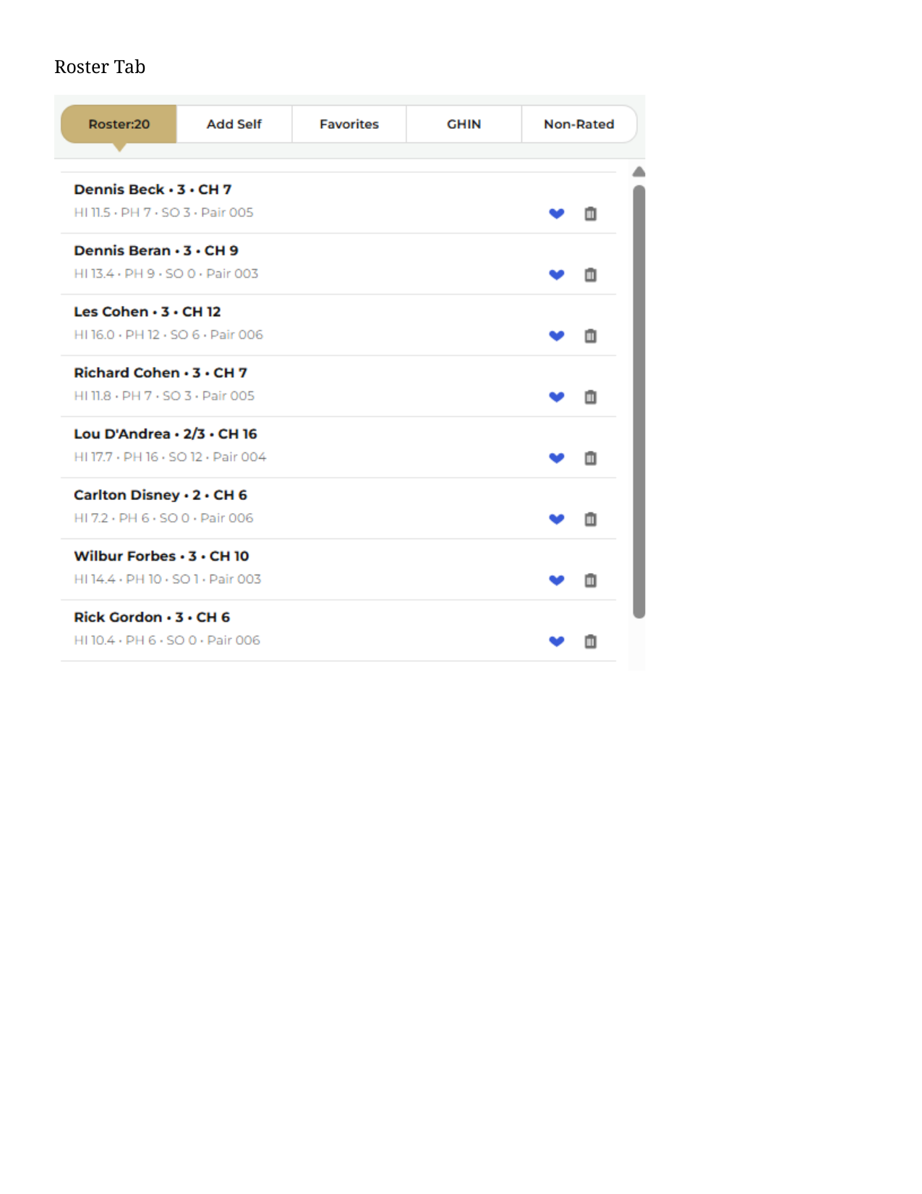  Figure 1 – Roster tab (enrolled roster list + favorite/remove). | 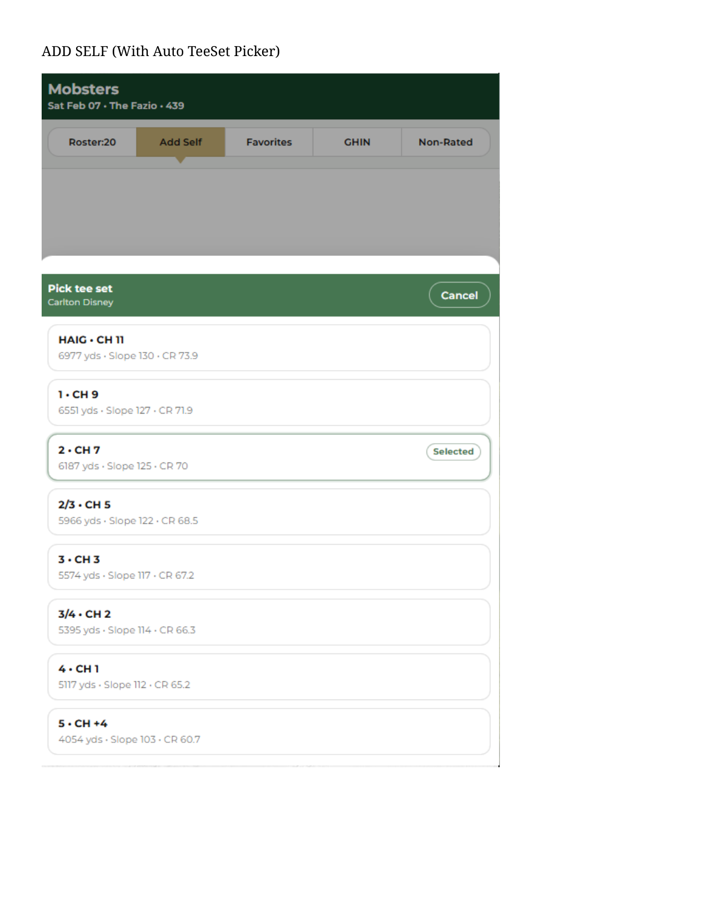  Figure 2 – Add Self (auto-launch tee picker; select tee to enroll).
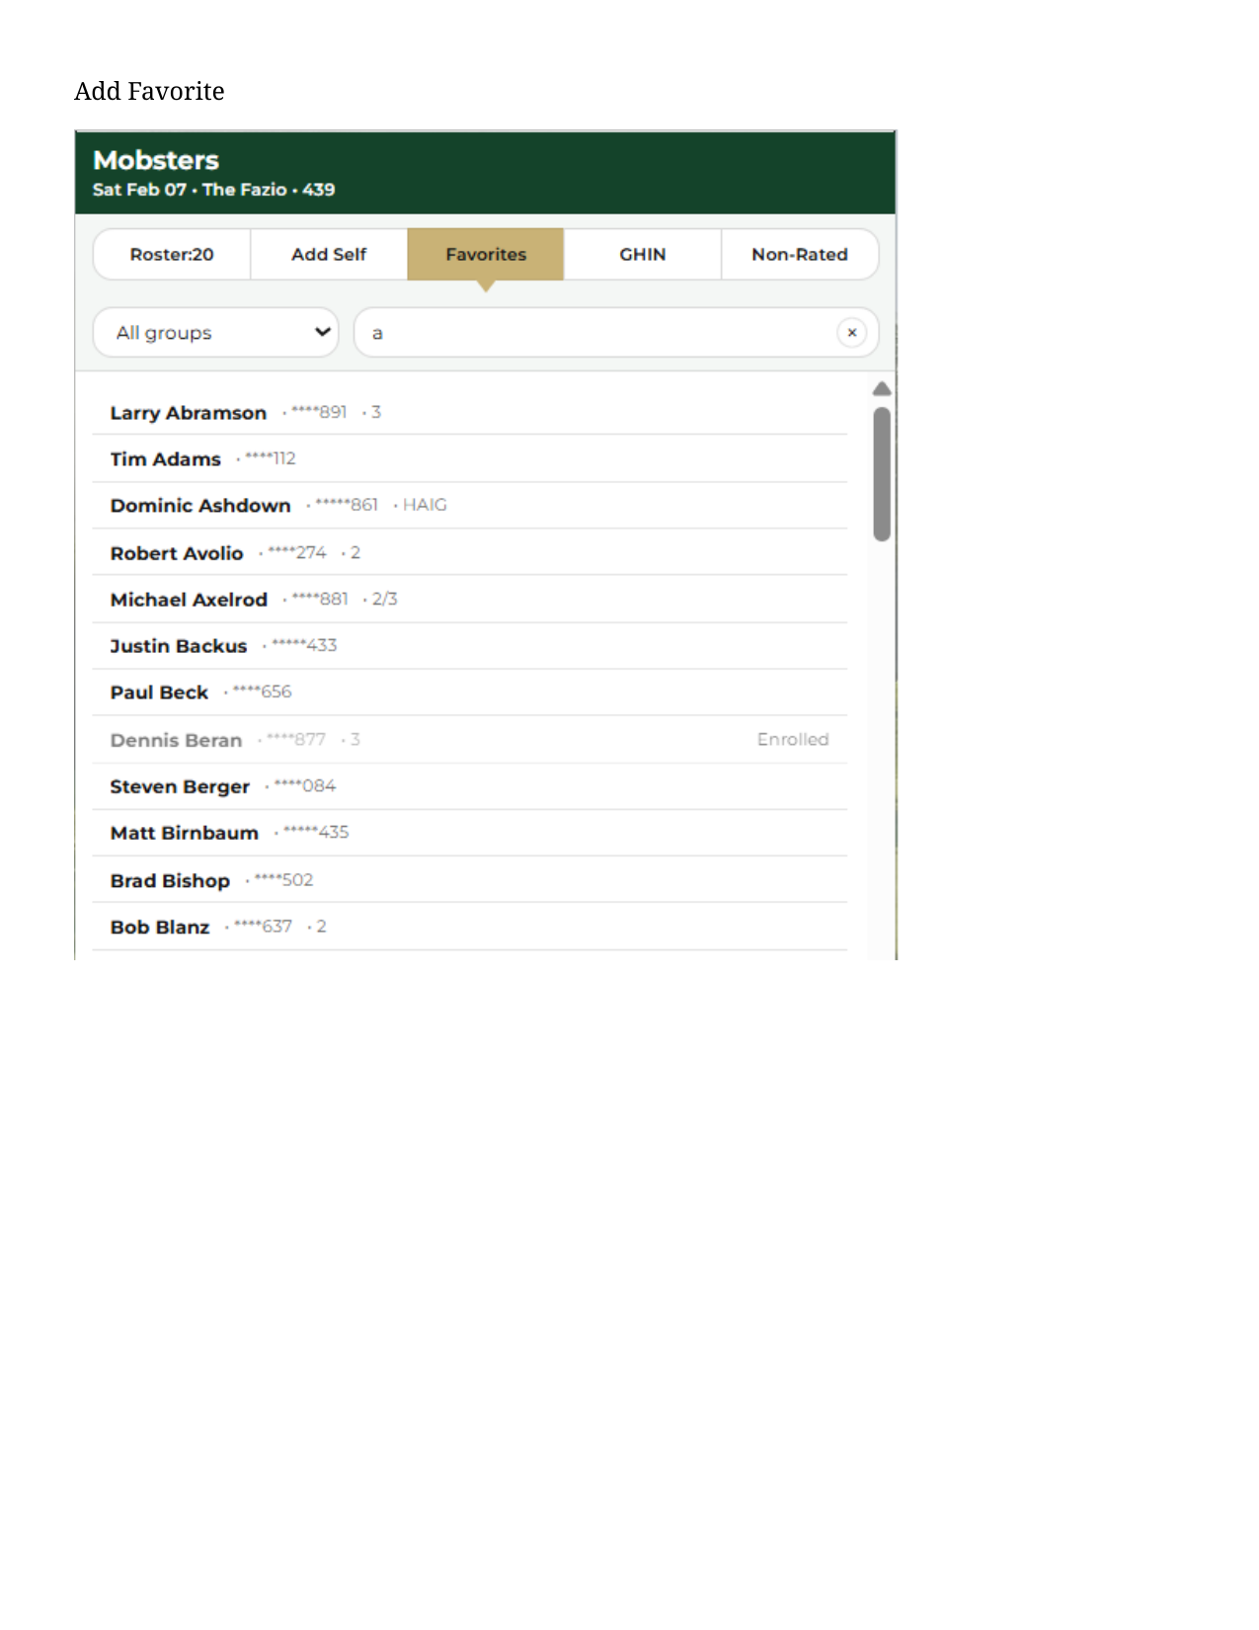  Figure 3 – Favorites (group filter + search; tap to enroll). | 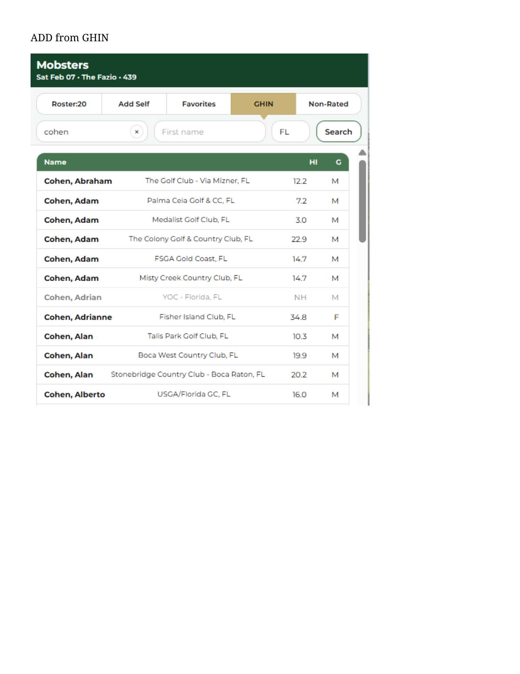  Figure 4 – GHIN search (search results; tap to enroll).
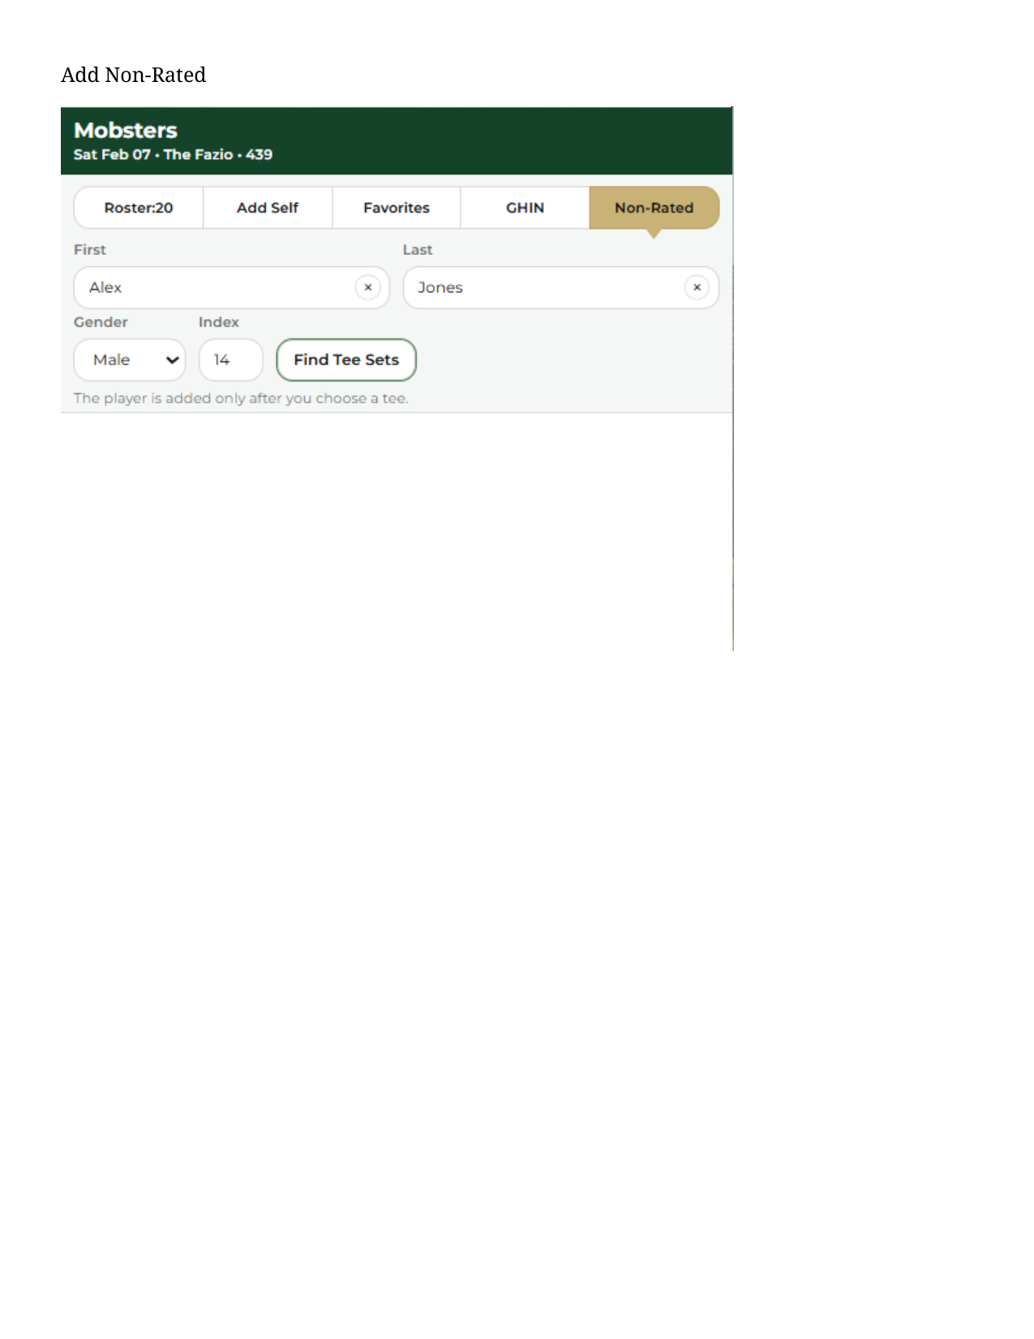
Figure 5 – Non-Rated (capture identity + index; tee selection required).

6. Functional Requirements

6.1 Global Page Requirements
- Page must operate in both Admin and Player portal modes (mode value provided by session/context).
- Game context (GGID, title, playDate, courseName, holes, allowance, privacy, adminGHIN) must be available at render time.
- All UI must use MatchAid tokens (Montserrat, brandPrimary header, segmentSelectedBg active tab, compact spacing) consistent with ma_shared.css.
- Bottom status line must support neutral/info/warn/error/success display states.
- All network calls must return JSON; non-JSON responses must surface a user-friendly status message and log details.
- Page requires Controls area to support the tabular navigation between tabs. Also supports tab level sorting, filtering, input entry, etc. Controls area is a peer structure to the body.

6.2 Roster Tab
- Acts as HOME for this page. Renders all enrolled players for the current GGID, sorted by last name.
- Row line 1: “Name • Tee • CH”. Row line 2: “HI • PH • SO • Pair”.
- Tap row → fetch tee options for that player and open Tee Picker modal with current tee highlighted (if any).
- Favorite (heart) icon: indicates whether the player exists in favorites; tap routes to Favorites maintenance (page or modal) without triggering row tap. Tapping an heart icon routes the user to the Favorite Players form where the user can edit/save a new favorite. This page and supporting code is already wired.
- Remove (trash) icon: removes the roster player (db_Players row) and immediately refreshes the roster list.

6.3 Add Self Tab
- Entering the tab auto-launches Tee Picker for the logged-in golfer (selfGhin/selfName from context).
- Selecting a tee enrolls the current user as a player (insert/update db_Players) and returns the UI to Roster tab.
- If tee options cannot be computed, show a warning in status line and keep the user on the current tab.

6.4 Favorites Tab
- If favorites are not loaded, the tab triggers a favorites load call and shows “Loading favorites…” status.
- Favorites list supports group filter (tags) and free-text search.
- Favorites already enrolled in roster show disabled/“Enrolled” and are not tappable.
- Tap a favorite → fetch tee options for that favorite player (supports NH favorites) and open Tee Picker modal.
- Optionally display last played tee on this course (from prior db_Players history for the same course).
- Favorite players sources from db_FavPlayers table

6.5 GHIN Tab
- Search inputs: Last name (required; numeric treated as GHIN lookup), optional First name, State defaulting to userState.
- Search results show: Name, Location, HI, Gender; enrolled players show Enrolled and are disabled.
- Tap a GHIN result → fetch tee options and open Tee Picker modal.

6.6 Non-Rated Tab
- Inputs: First, Last (required), Gender (M/F), Handicap Index (supports +/- and decimal).
- Find Tee Sets generates an internal NH id and requests tee options by Index (not by GHIN).
- Player is only inserted into db_Players after a tee is chosen.
- Show helper text: “The player is added only after you choose a tee.”

6.7 Tee Picker Modal
- Modal is bottom-sheet style with a Cancel button and tap-outside-to-dismiss behavior.
- Each tee option displays: Name • CH on line 1 and “Yards • Slope • CR” on line 2.
- Selecting an option calls Assign Tee, closes the modal, and updates roster + enrolled sets on success.
- If Assign Tee fails, show “Save failed” in status line and do not lose the user’s current tab context.

7. Endpoint / Function Inventory
The refactor should map the current Velo/HTML responsibilities to GoDaddy endpoints as follows (names are proposed and can be adjusted to match existing conventions):
Area | Current Wix Responsibility | Proposed GoDaddy Endpoint/Service | Notes
Init / hydrate | getStoredGameData + roster + favorites, then post INIT to HTML | /api/registrations/initRegistrations.php | Embed as window.__INIT__ in registrations.php
Roster query | wixData.query(db_Players).eq(GGID) | service_dbPlayers::listByGame($ggid) | Confirm function name. Reuse existing service file
Favorites query | wixData.query(db_FavPlayers).eq(userGHIN) | service_dbFavPlayers::listByUser($userGHIN) | Confirm function name. Reuse existing service file
GHIN search | be_getPlayersByName / be_getPlayersByID | /api/ghin/searchPlayers.php | Reuse existing GHIN proxy patterns
Tee options | be_buildTeeSetTags(Index|Player) | /api/registrations/teeOptions.php | Returns normalized TeeOption list
Assign tee / enroll | commitSelectedPlayerTee → delete+insert db_Players | /api/registrations/assignTee.php | Upsert pattern preferred; return updated roster
Remove player | deleteGamePlayer(row._id) | /api/registrations/removePlayer.php | Delete by primary key; return updated roster
Calculate Handicaps | be_

8. Data & Contracts

8.1 INIT payload (server → page JS)
Embed or return a JSON object with the following fields:
- mode: "player" | "admin"
- selfGhin, selfName
- intent (e.g., "quickEnrollSelf")
- userState (two-letter state)
- game: { gameId, title, playDate, playTime, facilityName, courseName, courseId, holes, allowance, privacy, adminGHIN }
- roster: array of roster rows (see 8.3)
- enrolledGhinSet: array of GHIN ids currently enrolled
- favorites: array of favorite rows (dbFav_* fields, optional lastCourse)

8.2 UI event contracts (page JS ↔ API)
- GET/POST /api/registrations/init.php → { ok, payload:{...INIT...} }
- POST /api/registrations/teeOptions.php → { ok, payload:{ teeOptions:[{teeSetId,name,ch,yards,slope,rating}], selectedTeeSetId } }
- POST /api/registrations/assignTee.php → { ok, payload:{ roster:[...], enrolledGhinSet:[...] } }
- POST /api/registrations/removePlayer.php → { ok, payload:{ roster:[...], enrolledGhinSet:[...] } }
- POST /api/ghin/searchPlayers.php → { ok, payload:{ results:[{ghin,name,hi,gender,city,state}], isTruncated } }

8.3 Normalized roster row (for rendering)
- { playerKey, _id, ggid, ghin, localId, firstName, lastName, displayName, gender, hi, ch, ph, so, teeSetId, teeSetName, teeSetSlope, teeSetDetails, pairingId, pairingPos, flightId, flightPos, clubId, clubName, creatorId, creatorName }
- Note: key names may remain in dbPlayers_* shape server-side; page JS should normalize once.

8.4 Non-Rated overlay contract
- NH players use an internally generated GHIN-like id (NH + timestamp + random).
- Client supplies overlay: { fullName, firstName, lastName, gender, hiText, handicap_index }.
- Server should treat NH as a valid identity but must not call GHIN profile lookup for NH ids.

9. Refactor Roadmap – Step-by-step
- Create /app/registrations/registrations.php with auth guard, chrome header/footer, and embed window.__INIT__ using server-side hydrate.
- Extract markup from the Wix HTML component into /app/registrations/registrations_view.php; replace inline tokens with ma_shared.css classes where available; keep page-specific CSS minimal.
- Implement /assets/pages/registrations.js: state model, tab renderers, tee modal, status line, and API call wrappers (reuse ma_shared.js postJson/router helpers).
- Implement /api/registrations/init.php + service layer: query roster (db_Players) and favorites (db_FavPlayers), enrich favorites with lastCourse tee for this course (optional).
- Implement /api/registrations/teeOptions.php: call existing GHIN tee/tag builder logic (or PHP equivalent) and return normalized teeOptions.
- Implement /api/registrations/assignTee.php: upsert db_Players row; compute PH/SO if applicable; return updated roster payload.
- Implement /api/registrations/removePlayer.php: delete roster row; return updated roster payload.
- Regression test: each tab behavior, tee selection, enrolled disabling, status messaging, and mobile overflow/viewport behavior.
- Cutover routing: update pageRouter.php / navigation to point Registrations to the new GoDaddy page.

10. Open Decisions / Placeholders
- Favorites maintenance: keep current navigation to a separate Favorites page, or replace with an inline modal on Registrations?
- Data ownership for NH players: confirm how/where NH identities should be stored beyond db_Players (if at all).
- Course-history enrichment for favorites: keep as optional Phase 2 if it adds query cost; confirm acceptable performance.
- Authorization: confirm whether Player portal can remove players or only self-manage, and whether Admin portal can remove any roster row.

Appendix A – Database Schema
describe db_Games; |  | describe `db_Players`; |  | describe db_FavPlayers;

FieldName | Type | Key | Default | Notes |  | FieldName | Type | Null | Key | Default | Notes |  | FieldName | Type | Null | Key | Default | Notes
_createdDate | timestamp |  | current_timestamp() | on add current_timestamp() |  | dbPlayers_GGID | int(11) | NO | MUL | NULL |  |  | dbFav_UserGHIN | text | YES |  | NULL
_updatedDate | timestamp |  | current_timestamp() | on update current_timestamp() |  | dbPlayers_CourseID | text | YES |  | NULL |  |  | dbFav_PlayerGHIN | text | YES |  | NULL
dbGames_AdminAssocID | text |  | NULL |  |  | dbPlayers_PlayerGHIN | text | YES |  | NULL |  |  | dbFav_PlayerName | text | YES |  | NULL
dbGames_AdminAssocName | text |  | NULL |  |  | dbPlayers_Name | text | YES |  | NULL |  |  | dbFav_PlayerMemberID | text | YES |  | NULL
dbGames_AdminClubID | text |  | NULL |  |  | dbPlayers_LName | text | YES |  | NULL |  |  | dbFav_PlayerEMail | text | YES |  | NULL
dbGames_AdminClubName | text |  | NULL |  |  | dbPlayers_Gender | text | YES |  | NULL |  |  | dbFav_PlayerMobile | text | YES |  | NULL
dbGames_AdminGHIN | text |  | NULL |  |  | dbPlayers_LocalID | text | YES |  | NULL |  |  | dbFav_PlayerTags | longtext | YES |  | NULL
dbGames_AdminName | text |  | NULL |  |  | dbPlayers_ClubID | text | YES |  | NULL |  |  | dbFav_PlayerLName | text | YES |  | NULL
dbGames_Allowance | int(11) |  | NULL |  |  | dbPlayers_ClubName | text | YES |  | NULL |  |  | dbFav_PlayerHI | text | YES |  | NULL
dbGames_BestBall | text |  | NULL |  |  | dbPlayers_HI | text | YES |  | NULL |  |  | dbFav_PlayerGender | text | YES |  | NULL
dbGames_BlindPlayers | longtext |  | NULL |  |  | dbPlayers_TeeSetID | text | YES |  | NULL
dbGames_Comments | text |  | NULL |  |  | dbPlayers_TeeSetName | text | YES |  | NULL
dbGames_Competition | text |  | NULL |  |  | dbPlayers_TeeSetSlope | text | YES |  | NULL
dbGames_CourseID | text |  | NULL |  |  | dbPlayers_CH | text | YES |  | NULL
dbGames_CourseName | text |  | NULL |  |  | dbPlayers_PH | text | YES |  | NULL
dbGames_FacilityID | text |  | NULL |  |  | dbPlayers_SO | text | YES |  | NULL
dbGames_FacilityName | text |  | NULL |  |  | dbPlayers_TeeTime | text | YES |  | NULL
dbGames_GameFormat | text |  | NULL |  |  | dbPlayers_FlightID | text | YES |  | NULL
dbGames_GameKey | text |  | NULL |  |  | dbPlayers_FlightPos | text | YES |  | NULL
dbGames_GGID | int(11) | PRI | NULL | auto_increment |  | dbPlayers_PairingID | text | YES |  | NULL
dbGames_HCEffectivity | text |  | NULL |  |  | dbPlayers_PairingPos | text | YES |  | NULL
dbGames_HCEffectivityDate | date |  | NULL | Different than Wix date |  | dbPlayers_StartHole | text | YES |  | NULL
dbGames_HCMethod | text |  | NULL |  |  | dbPlayers_StartHoleSuffix | text | YES |  | NULL
dbGames_HoleDeclaration | longtext |  | NULL |  |  | dbPlayers_TeeSetDetails | text | YES |  | NULL
dbGames_Holes | text |  | NULL |  |  | dbPlayers_PlayerKey | text | YES |  | NULL
dbGames_PlayDate | datetime |  | NULL | Different than Wix date-time |  | dbPlayers_Scores | text | YES |  | NULL
dbGames_PlayerDeclaration | text |  | NULL |  |  | dbPlayers_ScoreKeeper | text | YES |  | NULL
dbGames_PlayTime | time |  | NULL | Different than Wix Time |  | dbPlayers_CreatorID | text | YES |  | NULL
dbGames_Privacy | text |  | NULL |  |  | dbPlayers_CreatorName | text | YES |  | NULL
dbGames_RotationMethod | text |  | NULL |  |  | _createdDate | timestamp | NO |  | current_timestamp()
dbGames_ScoringBasis | text |  | NULL |  |  | _updatedDate | timestamp | NO |  | current_timestamp()
dbGames_ScoringMethod | text |  | NULL
dbGames_ScoringSystem | text |  | NULL
dbGames_Segments | text |  | NULL
dbGames_StablefordPoints | longtext |  | NULL
dbGames_StrokeDistribution | text |  | NULL
dbGames_TeeTimeCnt | text |  | NULL
dbGames_TeeTimeInterval | text |  | NULL
dbGames_TeeTimeList | text |  | NULL
dbGames_Title | text |  | NULL
dbGames_TOMethod | text |  | NULL

X. Data Mapping & Persistence Rules — db_Players
X.1 Purpose
The Registrations module persists roster membership for a selected game by inserting/updating rows in db_Players. Player enrollment occurs when a user selects a player and then selects a tee set. Tee changes for an already-enrolled golfer update the same logical record (implemented as delete + re-insert in the legacy logic).

X.2 Insert Mapping — New Player Add (db_Players INSERT)
When this happens
A golfer (GHIN or NH) is selected for the current game (GGID) and does not already exist in db_Players for that game.
User selects a tee set.
Business intent
Create a new roster row for the golfer in the current game, defaulting pairing/flight fields, and computing CH/PH/SO according to rules.
X.2.1 Field mapping table (New add)
db_Players column | Source / derivation
dbPlayers_GGID | Current game id in session (e.g., globalGGID)
dbPlayers_PlayerGHIN | Selected golfer GHIN (string). For Non-Rated players: "NH..."
dbPlayers_Name | first_name + " " + last_name
dbPlayers_LName | last_name
dbPlayers_LocalID | local_number (if provided)
dbPlayers_Gender | gender
dbPlayers_HI | handicap_index (stored as string when persisted)
dbPlayers_CourseID | Current game course id (e.g., storedGameData.dbGames_CourseID)
dbPlayers_TeeSetID | Selected tee id (stringified)
dbPlayers_TeeSetName | Tee set display name for selected tee
dbPlayers_TeeSetSlope | Tee set slope (stringified)
dbPlayers_CH | Course Handicap for selected tee (stringified; fallback "0")
dbPlayers_PH | Playing Handicap (see PH/SO rules)
dbPlayers_SO | Strokes Off (see PH/SO rules)
dbPlayers_TeeSetDetails | Tee payload object for the selected tee: { TeeSetRatingName, TotalPar, TotalYardage, Ratings, Holes } (fallback {} if not found)
dbPlayers_PairingID | "000" (default)
dbPlayers_PairingPos | "" (default)
dbPlayers_FlightID | "" (default)
dbPlayers_FlightPos | "" (default)
dbPlayers_ClubID | club_id (stringified if present)
dbPlayers_ClubName | club_name
dbPlayers_CreatorID | Current signed-in user id (e.g., globalUserID)
dbPlayers_CreatorName | Current signed-in user name (e.g., globalUserName)
dbPlayers_PlayerKey | "" (default)

X.3 Update Mapping — Existing Player Record Change (Tee Change)
When this happens
A golfer already exists in db_Players for the current GGID.
User selects a different tee set for the same golfer.
Implementation note (legacy Wix behavior)
Update is performed as delete existing record + insert new record to preserve the expected row shape.
X.3.1 No-op condition
If existing.dbPlayers_TeeSetID == selectedTeeSetId, the operation is treated as no change and no persistence is performed.
X.3.2 Fields preserved vs recomputed
Preserved from existing record
dbPlayers_PairingID
dbPlayers_PairingPos
dbPlayers_FlightID
dbPlayers_FlightPos
dbPlayers_PlayerKey
(Any other fields carried forward from the existing record that are not explicitly overwritten by the tee-change write)
Recomputed / overwritten on tee change
dbPlayers_TeeSetID
dbPlayers_TeeSetName
dbPlayers_TeeSetSlope
dbPlayers_TeeSetDetails
dbPlayers_CH
dbPlayers_PH
dbPlayers_SO
Player profile fields are refreshed from the currently selected player profile in memory:
dbPlayers_Name, dbPlayers_LName, dbPlayers_Gender, dbPlayers_LocalID, dbPlayers_HI, dbPlayers_ClubID, dbPlayers_ClubName
dbPlayers_CreatorID, dbPlayers_CreatorName are set to the current session user (the operator making the change).

X.4 PH / SO Computation Rules
X.4.1 Default values
On tee selection:
PH defaults to CH
SO defaults to 0
X.4.2 GHIN PHSO enrichment
If the golfer is a standard GHIN golfer and the course is conforming:
Conditions to allow GHIN PHSO call:
dbPlayers_PlayerGHIN does not start with "NH"
dbPlayers_CourseID does not start with "NC" (non-conforming course marker)
Then call GHIN PHSO service using:
golfer_id (player GHIN)
tee_set_id (selected tee)
tee_set_side (derived from game holes / side selection)
allowance (game allowance context)
Persist:
dbPlayers_PH = playing_handicap_display
dbPlayers_SO = shots_off
X.4.3 Non-Rated (NH) and Non-Conforming (NC) fallback
If the golfer is NH* or the course is NC*:
Skip GHIN PHSO service call
Persist:
PH = CH
SO = 0

X.5 Non-Rated (“NH”) Player Profile Mapping
When this happens
The selected player is a manual / non-rated entry represented by a synthetic GHIN beginning with "NH".
Mapping behavior
A player profile object is constructed by:
Fetching a baseline GHIN profile template (using the admin/session GHIN context)
Overlaying:
ghin = "NH..." (synthetic id)
handicap_index = overlay.handicap_index
gender = overlay.gender
first_name / last_name derived from overlay name input (split into first/last)
The resulting profile then follows the same db_Players insert mapping rules above.

Appendix B - Wix Back End Code Modules-

Overview
Refactor Summary — Handicap / TeeSet / PH-SO Backend Modules
1) be_buildTeeSetTags(...)
What it is
Builds the Tee Set “tag list” used by the UI for tee selection (chips/tags/picker). This is the canonical “tee options for this golfer/game” builder.
Inputs (contract)
- parmMode: "Player" or "Index"
- parmValue:
  - if "Player" → GHIN number
  - if "Index" → Handicap Index (HI)
- parmGender: "M" / "F" (must match tee set gender)
- parmGameData: must contain:
  - dbGames_CourseID
  - dbGames_Holes (tee_set_side, e.g. "All18", "F9", "B9" or your string contract)
- parmToken: GHIN bearer token
External dependency
- Calls be_getCourseHandicap(...) → GHIN course_handicaps.json response (tee_sets → ratings)
Output (contract)
Returns tagsArray[], sorted by slope desc, where each element includes:
- UI label/value
  - label = "<teeName> | CH:<course_handicap_display> | <yards> yds"
  - value = tee_set_id as string
- Normalized structured fields (important for your refactor)
  - teeSetID, teeSetName, holes_number, gender
  - playerCH (from rating.course_handicap_display)
  - teeSetSlope (from rating.slope_rating)
  - teeSetYards (computed sum of holes[].Length)
  - teeSetRating (from rating.course_rating)
- Raw GHIN payload passthrough
  - ratings, jsonSetRating
Must-preserve rules
- Filter tee sets by teeSet.gender === parmGender
- Filter ratings by rating.tee_set_side === parmGameData.dbGames_Holes
- Compute yards by summing teeSet.holes[].Length
- Sort highest slope first
Refactor note
This function is a great candidate to become a single PHP endpoint like:
- /api/ghin/teeSetsForGolfer.php
returning the above normalized schema (so UI rendering is stable across platforms).

2) be_recalculateGameHandicaps(parmGGID, parmPlayerGHIN, parmGameData, parmToken)
What it is
Recomputes HI and CH (and resets PH/SO placeholders) for:
- one golfer, or
- all golfers in a game
Inputs (contract)
- parmGGID: game id
- parmPlayerGHIN: specific GHIN or "allPlayers"
- parmGameData must include:
  - dbGames_Holes, dbGames_CourseID, dbGames_Allowance
  - dbGames_ScoringMethod (Gross vs Net behavior)
  - dbGames_HCEffectivity, dbGames_PlayDate, dbGames_HCEffectivityDate
Data access
- Queries db_Players (Wix Data)
- Filters out any player whose GHIN starts with "NH" (non-rated are excluded)
Behavior overview
For each eligible player:
- Determine if net play:
  - isNetPlay = dbGames_ScoringMethod !== "ADJ GROSS"
- If net play:
  - Compute effective HI using be_getHandicapbyPeriod(...) based on dbGames_HCEffectivity:
    - Low3, Low6, Low12
    - PlayDate → range with play date
    - Date → range with effectivity date
  - Fallback: call be_getPlayersByID(ghin) to get handicap_index
- Compute Course Handicap (CH):
  - be_getCourseHandicap("Index", txtPlayerHI, courseId)
  - Find tee set matching player gender and tee_set_id
  - Find rating matching tee_set_side == holes
  - If found and net play → valCH = rating.course_handicap
  - If not found → force tee name to "ReSelect Tee" (signals UI “invalid tee”)
- Update player record:
  - dbPlayers_HI = txtPlayerHI
  - dbPlayers_CH = valCH
  - dbPlayers_PH = valCH (placeholder; overwritten later by PH/SO calc)
  - dbPlayers_SO = "0"
  - dbPlayers_TeeSetName possibly set to "ReSelect Tee"
Output (contract)
Returns { status, message, groups, updated, allowance, errors }
- Note: groups is always 0 here (grouping done in PH/SO function)
Must-preserve rules
- Skip NH* players entirely
- If no eligible players → return “skipped no rated players”
- “ReSelect Tee” is a sentinel value that later blocks PH/SO calculations
Refactor note
In the HTML/PHP architecture, this likely becomes:
- /api/game/recalculateHandicaps.php (GGID + optional PlayerGHIN)
And you’ll want to preserve:
- the effectivity logic (Low3/6/12 vs Date vs PlayDate)
- the "ReSelect Tee" sentinel behavior
- the PH/SO placeholder semantics (PH initially equals CH)

3) be_calculateGamePHSO(parmType, parmData, parmGameData, parmToken)
What it is
Calculates Playing Handicap (PH) and Strokes Off (SO) using GHIN’s playing_handicaps.json endpoint.
Inputs (contract)
- parmType: "players" or "game"
  - "players" means caller provides the player list in parmData
  - "game" means this function queries db_Players for the game
- parmGameData must include:
  - dbGames_Holes, dbGames_Allowance
  - dbGames_Competition (PairPair vs PairField)
  - dbGames_GGID
  - dbGames_ScoringMethod (skip on ADJ GROSS)
Hard stop / skip conditions
- If ScoringMethod === "ADJ GROSS" → return “PH/SO skipped, Gross Play.”
Eligibility filter
Players are excluded if:
- dbPlayers_TeeSetName is "ReSelect Tee" (must be re-selected first)
(NOTE: This function does not explicitly skip NH*; it relies on data eligibility and tee selection. In practice, your upstream logic may avoid NH or may still allow manual HI input. Here, the payload uses handicap_index, so NH can still technically work if HI is meaningful.)
Grouping rules (VERY important)
Creates groups based on Competition:
- If PairPair:
  - group key = FlightID
  - skip players with missing/zero flight (unflighted)
- If PairField:
  - group key = PairingID
  - skip players with "000" or missing pairing (unpaired)
- Else:
  - group key = "ALL" (but in code it only becomes meaningful if competition not those values)
If no groups → returns “PH/SO Skipped. No pairings/matches.”
GHIN call pattern (critical for refactor)
- One GHIN call per group
- Request body uses manual golfer mode (not golfer_id):
- { "golfers": [
- { "handicap_index": <Number>, "tee_set_id": <Number>, "tee_set_side": <holes> },
- ...
- ]}
- Response is indexed by allowance:
  - phso[varAllowance]
- Output keys are manual_golfer_1...N in the same order as sent.
- For each player in the group:
  - dbPlayers_PH = playing_handicap
  - dbPlayers_SO = shots_off
Must-preserve rules
- Skip entirely for Gross play
- Grouping by competition (and the “skip unpaired/unflighted” semantics)
- Use handicap_index input mode, not golfer_id
- Map response by request order (manual_golfer_#)
- Update only PH and SO (no other player fields)
Refactor note
This maps cleanly to:
- /api/game/calcPHSO.php
You must preserve the grouped calling pattern, because it’s a key behavior (and performance characteristic).

4) be_getHandicapbyPeriod(parmPeriod, parmBegDate, parmEndDate, parmGolfers, parmToken)
What it is
Retrieves “low HI” values from GHIN for several time windows (Low3/6/12 or Date Range).
Inputs (contract)
- parmPeriod: Low12 | Low6 | Low3 | Range
- parmBegDate, parmEndDate required only for Range in YYYY-MM-DD
- parmGolfers: GHIN list or scalar
- parmToken: required
Key helper behavior
- normalizeGhinNumberArray:
  - accepts string/number/object array
  - extracts GHIN via ghin, GHINNumber, ghinNumber, dbPlayers_PlayerGHIN
  - only keeps digits-only values
  - unique list
Output
Returns raw GHIN JSON payload (unmodified)
Must-preserve rules
- Strictly requires token
- For Range: date strings should be passed as YYYY-MM-DD (already enforced)

5) be_getCourseHandicap(parmType, parmValue, parmCourse, parmToken)
What it is
Calls GHIN course_handicaps.json to get tee sets and ratings for course handicap calculation.
Key behavior
- If course id begins with "NC" (non-conforming):
  - returns empty [] (currently stubbed)
- Else:
  - If parmType === "Player" → query by golfer_id=<GHIN>
  - Else → query by handicap_index=<HI>
- Returns GHIN JSON payload
Must-preserve rules
- The "NC" prefix is a special marker used throughout your system.
- The two query modes must remain available (Player vs Index).

6) be_checkHandicapDataFactors(originalGameData, revisedGameData)
What it is
A “dirty check” — determines whether a game edit requires handicap recomputation.
Fields that trigger recalculation if changed
- dbGames_HCMethod
- dbGames_Competition
- dbGames_CourseID
- dbGames_Holes
- dbGames_StrokeDistribution
- dbGames_ScoringMethod
- dbGames_HCEffectivity
- dbGames_HCEffectivityDate
- dbGames_Allowance
Refactor note
In PHP, this becomes a very clean, deterministic function that can run:
- before saving game changes (to decide whether to enqueue recalculation)
- or after save (to decide whether to call recalculation immediately)

Key Refactor “Gotchas” to Preserve
A) Sentinel values drive downstream behavior
- "ReSelect Tee" in dbPlayers_TeeSetName is used to:
  - indicate tee mismatch after handicap recalculation
  - exclude player from PH/SO calculation
B) Gross vs Net changes behavior in two places
- be_recalculateGameHandicaps: HI and CH logic only meaningful in net play
- be_calculateGamePHSO: hard skip for ADJ GROSS
C) Competition drives grouping rules for PH/SO
- PairPair → group by flight, skip unflighted
- PairField → group by pair, skip unpaired
- If nobody qualifies → “No pairings/matches” skip message
D) PH/SO is intentionally two-phase
- Phase 1: CH/HI recalculation sets PH=CH and SO=0 placeholder
- Phase 2: group-based GHIN call overwrites PH and SO

Concrete Recommendations for the HTML+PHP Refactor
1) Normalize as API endpoints with stable JSON contracts
Suggested endpoints (names consistent with your current structure):
- /api/ghin/courseHandicap.php → wraps be_getCourseHandicap
- /api/ghin/handicapByPeriod.php → wraps be_getHandicapbyPeriod
- /api/game/recalculateHandicaps.php → wraps be_recalculateGameHandicaps
- /api/game/calcPHSO.php → wraps be_calculateGamePHSO
- /api/ghin/buildTeeSetTags.php → wraps be_buildTeeSetTags
2) Keep the “tag schema” exactly as-is
Your front end will thank you if tee option objects remain identical:
label/value + teeSetID/Name/Slope/Yards/Rating + jsonSetRating
3) Preserve the group call pattern to GHIN
Don’t move to “one call per player” — it will change performance and (worse) change matching semantics.
4) Continue using “NC” and “NH” as first-class markers
They’re deeply embedded in behavior. Don’t “sanitize them away” during refactor.

Velo Code
import { fetch } from 'wix-fetch';
import wixData from 'wix-data';
import { be_getPlayersByID } from 'backend/GHIN_API_Players.jsw';

export async function be_buildTeeSetTags(parmMode, parmValue, parmGender, parmGameData, parmToken = null) {
const tagsArray = [];

let txtCourseID = parmGameData.dbGames_CourseID
let txtHoles = parmGameData.dbGames_Holes

let courseCHData;
if (parmMode === "Player") {
courseCHData = await be_getCourseHandicap("Player", parmValue, txtCourseID, parmToken); //parmValue = GHIN
//console.log("Course CH Data", courseCHData)
} else {
courseCHData = await be_getCourseHandicap("Index", parmValue, txtCourseID, parmToken); //parmValue = HI
}

if (!courseCHData || !Array.isArray(courseCHData.tee_sets)) {
return [];
}

for (const teeSet of courseCHData.tee_sets) {
if (teeSet.gender !== parmGender) continue;

for (const rating of teeSet.ratings) {
if (rating.tee_set_side !== txtHoles) continue;

// ---- yards calculation (legacy behavior, now preserved as data) ----
let totalLength = 0;
if (Array.isArray(teeSet.holes)) {
totalLength = teeSet.holes.reduce(
(sum, hole) => sum + (Number(hole.Length) || 0),
0
);
}

const formattedYards = totalLength.toLocaleString();

// ---- legacy label (unchanged) ----
const label = `${teeSet.name} | CH:${rating.course_handicap_display} | ${formattedYards} yds`;
const value = teeSet.tee_set_id.toString();

// ---- PUSH NORMALIZED + STRUCTURED DATA ----
tagsArray.push({
// legacy / UI
label,
value,

// identifiers
teeSetID: teeSet.tee_set_id,
teeSetName: teeSet.name,
holes_number: teeSet.holes_number,
gender: teeSet.gender,

// handicap data
playerCH: rating.course_handicap_display,
teeSetSlope: rating.slope_rating,

// ⭐ NEW: explicit structured values
teeSetYards: totalLength, // numeric yards
teeSetRating: rating.course_rating ?? "", // course rating (GHIN)

// raw GHIN payloads (unchanged)
ratings: teeSet.ratings,
jsonSetRating: rating
});
}
}

// Highest slope first (legacy behavior)
tagsArray.sort(
(a, b) => parseInt(b.teeSetSlope) - parseInt(a.teeSetSlope)
);

return tagsArray;
}
export async function be_recalculateGameHandicaps(parmGGID, parmPlayerGHIN, parmGameData, parmToken) {
//Inputs: parmPlayerGHIN is either a single player, or text value "allPlayers". Iff 'allPlayers", then function needs to query all game players
try {
const txtHoles = parmGameData.dbGames_Holes;
const txtCourseID = parmGameData.dbGames_CourseID;
const varAllowance = String(parmGameData.dbGames_Allowance || "100");

let query = wixData.query("db_Players").eq("dbPlayers_GGID", parmGGID);
if (parmPlayerGHIN !== "allPlayers") {
query = query.eq("dbPlayers_PlayerGHIN", parmPlayerGHIN);
}

const res = await query.find({ consistentRead: true });
const playerData = (res.items || []).filter(p => !String(p.dbPlayers_PlayerGHIN || "").startsWith("NH"));

if (!playerData.length) {
return {
status: "ok",
message: "Handicap calculation skipped-No rated players.",
groups: 0,
updated: 0,
allowance: varAllowance
};
}

let updatedCount = 0;
let errorCount = 0;

// NOTE: keeping your per-player logic, just adding counting + safe error handling
await Promise.all(playerData.map(async (player) => {
try {
const txtGHIN = player.dbPlayers_PlayerGHIN;
const txtGender = player.dbPlayers_Gender;
const txtTeeSetSide = txtHoles;
const txtTeeSetID = parseInt(player.dbPlayers_TeeSetID, 10);

let txtTeeSetName = player.dbPlayers_TeeSetName;
let valCH = 0;
let txtPlayerHI = "0";

const isNetPlay = (parmGameData.dbGames_ScoringMethod !== "ADJ GROSS");

// 1) Determine HI (Net play only)
if (isNetPlay) {
let jsonPlayerHI = [];

switch (parmGameData.dbGames_HCEffectivity) {
case "Low3":
case "Low6":
case "Low12": {
jsonPlayerHI = await be_getHandicapbyPeriod(parmGameData.dbGames_HCEffectivity, null, null, txtGHIN, parmToken);
break;
}
case "PlayDate": {
jsonPlayerHI = await be_getHandicapbyPeriod("Range", toYMD(parmGameData.dbGames_PlayDate), toYMD(parmGameData.dbGames_PlayDate), txtGHIN, parmToken);
break;
}
case "Date": {
jsonPlayerHI = await be_getHandicapbyPeriod("Range", toYMD(parmGameData.dbGames_HCEffectivityDate), toYMD(parmGameData.dbGames_HCEffectivityDate), txtGHIN, parmToken);
break;
}
default: {
console.log("Invalid HC-Effectivity option", parmGameData.dbGames_HCEffectivity);
break;
}
}

const row = Array.isArray(jsonPlayerHI?.d) ? jsonPlayerHI.d[0] : null;

if (row && row.LowHIValue != null) {
txtPlayerHI = String(row.LowHIValue);
} else {
const playerGHINData = await be_getPlayersByID(txtGHIN, parmToken);
txtPlayerHI = String(playerGHINData?.golfers?.[0]?.handicap_index ?? "0");
}
}

// 2) Get Course Handicap (CH) based on TeeBox
const json = await be_getCourseHandicap("Index", txtPlayerHI, txtCourseID, parmToken);

let foundCH = false;
if (json && Array.isArray(json.tee_sets)) {
for (const set of json.tee_sets) {
if (set.gender === txtGender && set.tee_set_id === txtTeeSetID) {
const rating = (set.ratings || []).find(r => r.tee_set_side === txtTeeSetSide);
if (rating) {
foundCH = true;
if (isNetPlay) valCH = rating.course_handicap;
}
break;
}
}
}

if (!foundCH) {
txtTeeSetName = "ReSelect Tee";
}

// 3) Update player record
const updatedPlayer = {
...player,
dbPlayers_TeeSetName: txtTeeSetName,
dbPlayers_HI: txtPlayerHI,
dbPlayers_CH: String(valCH),
dbPlayers_PH: String(valCH), // PH set here as CH placeholder; PH-SO will overwrite later
dbPlayers_SO: "0"
};

await wixData.update("db_Players", updatedPlayer);
updatedCount++;

} catch (err) {
errorCount++;
console.error(`Error updating player ${player?.dbPlayers_PlayerGHIN}:`, err);
}
}));

// If some failed, return warn (still "ok" is fine, but warn is more informative)
const status = (errorCount > 0) ? "ok" : "ok";
const severityHint = (errorCount > 0) ? " (some players failed)" : "";

return {
status: "ok",
message: `Handicaps calculated for ${updatedCount} players`,
groups: 0,
updated: updatedCount,
allowance: varAllowance,
errors: errorCount
};

} catch (err) {
return {
status: "error",
message: `Handicap calculation failed: ${err?.message || err}`,
groups: 0,
updated: 0,
allowance: String(parmGameData?.dbGames_Allowance || "100")
};
}
}

export async function be_calculateGamePHSO(parmType, parmData, parmGameData, parmToken) {
//Input for parmType is "players" or "game" If "players", the players array is supplied, otherwise retrieve it here
//
const myToken = parmToken;

const txtHoles = parmGameData.dbGames_Holes;
const varAllowance = String(parmGameData.dbGames_Allowance || "100");
const txtCompetition = parmGameData.dbGames_Competition; // "PairPair" | "PairField"
const txtGGID = parmGameData.dbGames_GGID;
const isGrossPlay = (parmGameData.dbGames_ScoringMethod === "ADJ GROSS")
const isNetPlay = (parmGameData.dbGames_ScoringMethod !== "ADJ GROSS")

if (isGrossPlay) return {
status: "ok",
message: "PH/SO skipped, Gross Play.",
groups: 0,
updated: 0,
allowance: varAllowance
};

// 1) Acquire players
let players = [];
if (parmType === "players") {
players = Array.isArray(parmData) ? parmData : [];
} else {
const res = await wixData.query("db_Players")
.eq("dbPlayers_GGID", txtGGID)
.limit(1000)
.find({ consistentRead: true });
players = res.items || [];
}

// 2) Skip records if the player has an undefined teesetname
//const rated = (players || []).filter(p => !String(p.dbPlayers_PlayerGHIN || "").startsWith("NH"));
const eligible = (Array.isArray(players) ? players : []).filter(p =>
String(p.dbPlayers_TeeSetName || "").trim() !== "ReSelect Tee"
);

// 3) Group players based on competition rules
const groups = new Map(); // key -> array of players

for (const p of eligible) {
let key = "ALL";

if (txtCompetition === "PairPair") {
const flight = String(p.dbPlayers_FlightID || "").trim();
if (flight && flight !== "0") key = flight; else continue; // skip unflighted
} else if (txtCompetition === "PairField") {
const pair = String(p.dbPlayers_PairingID || "").trim();
if (pair && pair !== "000") key = pair; else continue; // skip unpaired
}

if (!groups.has(key)) groups.set(key, []);
groups.get(key).push(p);
}

// If groups are empty exit function.
if (groups.size === 0) {
return {
status: "ok",
message: "PH/SO Skipped. No pairings/matches.",
groups: 0,
updated: 0,
allowance: varAllowance
};
}

const GHINurl = "https://api.ghin.com/api/v1/playing_handicaps.json";
let updatedCount = 0;
let groupCount = 0;

// 4) Process each group: call GHIN once per group, then update those players
for (const groupPlayers of groups.values()) {
groupCount++;

const parmGolfers = groupPlayers.map(p => ({
handicap_index: Number(p.dbPlayers_HI || 0), // <-- key change (effective HI)
tee_set_id: Number(p.dbPlayers_TeeSetID),
tee_set_side: txtHoles
}));

const phso = await fetch(GHINurl, {
method: "POST",
headers: {
accept: "application/json",
"Content-Type": "application/json",
Authorization: "Bearer " + myToken
},
body: JSON.stringify({ golfers: parmGolfers })
}).then(async (resp) => {
const text = await resp.text();
if (!resp.ok) throw new Error(`PHSO failed: ${resp.status} ${resp.statusText} | ${text.slice(0, 500)}`);
return text ? JSON.parse(text) : {};
});

//console.log("phso",phso)

const bucket = phso?.[varAllowance] || {};
await Promise.all(groupPlayers.map(async (p, idx) => {
// When using handicap_index input, GHIN returns manual_golfer_1..N in request order
const key = `manual_golfer_${idx + 1}`;
const phsoData = bucket[key];

const ph = phsoData?.playing_handicap ?? "0";
const so = phsoData?.shots_off ?? "0";

await wixData.update("db_Players", {
...p,
dbPlayers_PH: String(ph),
dbPlayers_SO: String(so)
});

updatedCount++;
}));
}

return {
status: "ok",
message: `PH/SO calculated for ${updatedCount} players`,
groups: groupCount,
updated: updatedCount,
allowance: varAllowance
};
}

export async function be_getHandicapbyPeriod(parmPeriod, parmBegDate, parmEndDate, parmGolfers, parmToken) {

const myToken = String(parmToken || "").trim();
if (!myToken) throw new Error("Get handicap by period: missing token");

let GHINurl = "";
if (parmPeriod === "Low12") GHINurl = "https://api.ghin.com/api/v1/golfers/low_hi_last_year.json";
else if (parmPeriod === "Low6") GHINurl = "https://api.ghin.com/api/v1/golfers/low_hi_last_6months.json";
else if (parmPeriod === "Low3") GHINurl = "https://api.ghin.com/api/v1/golfers/low_hi_last_3months.json";
else if (parmPeriod === "Range") GHINurl = "https://api.ghin.com/api/v1/golfers/low_hi_date_range.json";
else throw new Error("Get handicap by period: Invalid Period " + parmPeriod);

// If you're already passing an array of GHIN strings, you can skip normalization.
// Keeping it here is fine.
const ghinNumber = normalizeGhinNumberArray(parmGolfers);
if (!ghinNumber.length) throw new Error("Get handicap by period: missing golfer GHIN list");

const requestBody = { ghinNumber };

if (parmPeriod === "Range") {
const DateBegin = String(parmBegDate || "").slice(0, 10);
const DateEnd = String(parmEndDate || "").slice(0, 10);
if (!DateBegin || !DateEnd) throw new Error("Get handicap by period: Range requires parmBegDate and parmEndDate (YYYY-MM-DD)");
requestBody.DateBegin = DateBegin;
requestBody.DateEnd = DateEnd;
}

const resp = await fetch(GHINurl, {
method: "POST",
headers: {
accept: "application/json",
"Content-Type": "application/json",
Authorization: "Bearer " + myToken
},
body: JSON.stringify(requestBody)
});

if (!resp.ok) {
const errText = await resp.text();
throw new Error(`GHIN low_hi failed: ${resp.status} ${resp.statusText} | ${errText.slice(0, 500)}`);
}

// ✅ This returns the raw GHIN JSON payload, unmodified
return await resp.json();
}

export function be_getCourseHandicap(parmType, parmValue, parmCourse, parmToken = null) {
const myToken = parmToken
if (parmCourse.slice(0, 2) === "NC") {
//if it is a non conforming course, return
//const playerGHINData = be_getPlayersByID(parmGHIN) //not used
//let txtPlayerHI = playerGHINData[0].handicap_index
const txtPlayerHI = "0"
const NCCourseData = [] //nonConformingCourse(parmCourse, txtPlayerHI)
return NCCourseData
}
let GHINurl
if (parmType === "Player") { //Get course handicap by player, or by HI. Effective Date would add this string &played_at=06%2F01%2F2025 where %2F = "/"
GHINurl = "https://api.ghin.com/api/v1/course_handicaps.json?golfer_id=" + parmValue + "&course_id=" + parmCourse; //&played_at=08%2F01%2F2025
} else {
GHINurl = "https://api.ghin.com/api/v1/course_handicaps.json?handicap_index=" + parmValue + "&course_id=" + parmCourse;
//https://api.ghin.com/api/v1/course_handicaps.json?handicap_index=18.4&course_id=3090
}
return fetch(GHINurl, {
method: 'GET',
headers: {
'accept': 'application/json',
'Content-Type': 'application/json',
'Authorization': 'Bearer ' + myToken
}
})
.then((httpResponse) => {
if (httpResponse.ok) {
//console.log("Get Course Handicap JSON: ", httpResponse);
return httpResponse.json();
} else {
return Promise.reject("Get Course Handicap fetch did not succeed" + httpResponse.statusText);
}
});
}

export function be_checkHandicapDataFactors(parmOriginalGameData, parmRevisedGameData) {
if (parmOriginalGameData === parmRevisedGameData) { return false }

//if any of the values below have changed, return true
if (String(parmOriginalGameData.dbGames_HCMethod) !== String(parmRevisedGameData.dbGames_HCMethod)) { return true }
if (String(parmOriginalGameData.dbGames_Competition) !== String(parmRevisedGameData.dbGames_Competition)) { return true }
if (String(parmOriginalGameData.dbGames_CourseID) !== String(parmRevisedGameData.dbGames_CourseID)) { return true }
if (String(parmOriginalGameData.dbGames_Holes) !== String(parmRevisedGameData.dbGames_Holes)) { return true }
if (String(parmOriginalGameData.dbGames_StrokeDistribution) !== String(parmRevisedGameData.dbGames_StrokeDistribution)) { return true }
if (String(parmOriginalGameData.dbGames_ScoringMethod) !== String(parmRevisedGameData.dbGames_ScoringMethod)) { return true }

if (parmOriginalGameData.dbGames_HCEffectivity !== parmRevisedGameData.dbGames_HCEffectivity) { return true }
if (parmOriginalGameData.dbGames_HCEffectivityDate !== parmRevisedGameData.dbGames_HCEffectivityDate) { return true }
if (parmOriginalGameData.dbGames_Allowance !== parmRevisedGameData.dbGames_Allowance) { return true }

return false
}

//HELPERS
function toYMD(d) {
if (!d) return null;

// If it's already a Y-M-D string, do NOT round-trip through Date()
if (typeof d === "string") {
const s = d.trim();
if (/^\d{4}-\d{2}-\d{2}$/.test(s)) return s;

// If it's some other string, fall through to Date parse below
}

const dt = (d instanceof Date) ? d : new Date(d);
if (isNaN(dt.getTime())) return null;

// Use LOCAL date parts
const y = dt.getFullYear();
const m = String(dt.getMonth() + 1).padStart(2, "0");
const day = String(dt.getDate()).padStart(2, "0");
return `${y}-${m}-${day}`;
}
function normalizeGhinNumberArray(parmGolfers) {
if (parmGolfers == null) return [];

const arr = Array.isArray(parmGolfers) ? parmGolfers : [parmGolfers];

const out = [];
const seen = new Set();

for (const g of arr) {
let v = "";
if (typeof g === "string" || typeof g === "number") v = String(g).trim();
else if (g && typeof g === "object") v = String(g.ghin || g.GHINNumber || g.ghinNumber || g.dbPlayers_PlayerGHIN || "").trim();

if (!v) continue;
if (!/^\d+$/.test(v)) continue;
if (seen.has(v)) continue;

seen.add(v);
out.push(v);
}
return out;
}

